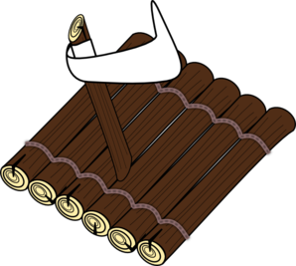

Our

R.A.F.T.

to new places!

F- Farewell

Say goodbye to people, places, pets and possessions that you are leaving behind.

T- Thinking Destination

Think of all the great new things you will experience.

A-Appreciate

Tell people how much you will miss them and give them something (a letter, a trinket) that tells them how much you care for them

R- Reach Out

Forgive people who have made you mad and say sorry to those who you have made mad.